**ASR 5013 Bin Utilization report**

Date: 30-01-2015

**Description**

To generate bin utilization report from daily storage snapshot data.

Report and % ofbin utilization is target for Rack bin type location only at this time,

the shelf bin locations is no required in this time.

Report source: from Billing – Inventory Storage report from SAP.

|  |  |  |  |  |  |  |  |  |
| --- | --- | --- | --- | --- | --- | --- | --- | --- |
| **BD RDC Bin Location Utilization** | | | | |  |  |  |  |
| Plant | Ty. | Storage bin | Bin Type | % of Bin Utilization | Material | Batch | On Hand Stock | Per Pallet  Quantities (EA) |
| 3091 | 402 | J3330J2 | Rack | 92% | 367958 | 4294311 | 35,000 | 38,000 |
| 3091 | 402 | J3330G3 | Rack | 92% | 367958 | 4294311 | 35,000 | 38,000 |
| 3091 | 402 | J3330G2 | Rack | 100% | 367839 | 4276268 | 66,000 | 66,000 |
| 3091 | 402 | J3330E3 | Rack | 92% | 367958 | 4294311 | 35,000 | 38,000 |
| 3091 | 402 | J3330A2 | Rack | 95% | 367953 | 4265245 | 35,000 | 37,000 |
| 3091 | 402 | J3330A1 | Rack | 94% | 367955 | 4282302 | 48,000 | 51,000 |
| 3091 | 402 | J3329L3 | Rack | 92% | 367958 | 4294311 | 35,000 | 38,000 |
| 3091 | 402 | J3329L2 | Rack | 100% | 367839 | 4276268 | 66,000 | 66,000 |

% of Bin Utilization = (On-hand stock / Quantity per pallet) * 100%

* To combine % if multiple products in same bin

** [04/02] do not require to combine, as user require view the detail SKU/Batch information.

The current Bin type utilization formula will be applicable for Rack location only.

=========================================================================

**From:** Zhi Ai, Huang   
**Sent:** Wednesday, 04 February, 2015 9:55 AM  
**To:** Chan, Pei-Fong  
**Cc:** Jack, Fong  
**Subject:** RE: BD RDC - Automation of Bin Utilization

Hi PeiFong,

Then, to display by SKU/Batch level. we will do some massage from report before action.

cid:image005.png@01D0405F.659E5350

*Best Regards,*

***ZhiAi, HUANG (Mr)***

*Senior Executive*

*Contract Logistics/SCM, Operations*

*Schenker Singapore (Pte) Ltd*

*5 Tuas View Lane, Singapore 637291*

*DID: +65 6795 2572  Mobile: +65 8383 8397*

**From:** Chan, Pei-Fong   
**Sent:** Tuesday, February 03, 2015 10:23 AM  
**To:** Zhi Ai, Huang  
**Cc:** Jack, Fong  
**Subject:** RE: BD RDC - Automation of Bin Utilization

Hi Zhi Ai,

Refer to your report format,

regarding the request to combine % of bin utilization if there’re multiple products in the same bin,

We have problem to display the combined/ grouping the Utilization % and at the same time display the SKU/Batch detail in same row.

In order to display the Sum of %, we will have **to group the data by Storage Bin and display as below format:**

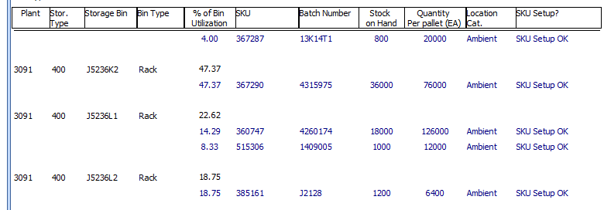

How do you want it to be listed in excel if report is downloaded ?

We can either display

1. the Summary ( highlighted in Yellow) ,  or
2. Detail at SKU Level ( highlighted in Blue)



Please review and confirm your request again. Thanks.

**The below format is group by at SKU/Batch Level, BUT not able to Combine the % for multiple SKUs in same Bin.**

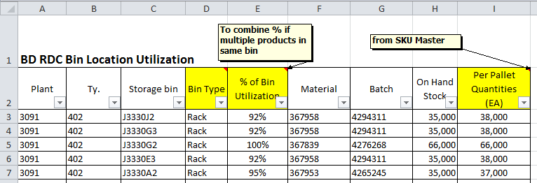

Best Regards,

Pei Fong Chan (Ms)

IT Solutioning Department

**Update 2015.02.05**

**WMS REPORT:**

* **Storage -> Bin Utilization Report**

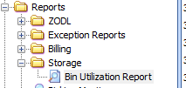

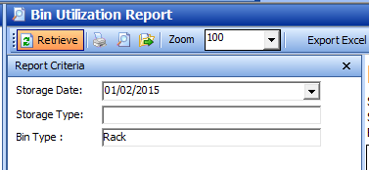

Notes:

Bin type = NA mean the Location master is not setup in WMS

“SKU Setup” field is to indicate if the SKU master (qty per pallet) has setup correctly in WMS.

